Building an AI-Based Content Creation Platform Using React, Flask, and Fine-Tuned Language Models

Authors
Rajeshwari Kodulkar, Department of Information Technology, DYPCOE, Akurdi Pune, India
[Second Author Name], [Affiliation]
[Additional Authors and Affiliations as necessary]
Corresponding Author
[Corresponding Author Name]
[Affiliation]
[Email Address]
[Phone Number]
Abstract
Background:
The increasing popularity of AI in creative domains has paved the way for content-generation platforms capable of storytelling, illustration, and voice synthesis. This study presents Skibidi Content, an AI-driven web application that enables users to generate interactive stories, illustrations, Instagram posts, quizzes, and audio outputs based on user inputs.
Methods:
The platform backend was built using Flask and SQLite, supporting RESTful APIs for operations like story generation, text-to-speech, and quiz creation. Fine-tuning of the Phi-2 language model was performed using PEFT (LoRA) techniques. Frontend development employed React.js and React Router, providing seamless navigation and story creation interfaces.
Results:
The system successfully generated consistent storylines, AI-based illustrations, quizzes and Instagram posts. Offline inference using the GGUF-optimized Phi-2 model ensured fast and efficient content generation. Integration with gTTS and Pollinations.ai enhanced multimedia output.
Conclusion:
This research demonstrates that combining lightweight, fine-tuned AI models with efficient web frameworks can produce highly functional and user-friendly AI content platforms, opening avenues for education, entertainment, and creative industries.
Keywords
AI content generation, Flask, React.js, Phi-2 fine-tuning, storytelling, text-to-speech.
Introduction
The field of AI-driven content generation has experienced substantial growth, leading to the development of platforms capable of producing various creative outputs, including stories, illustrations, and voice synthesis. This research introduces "Skibidi Content," an AI-driven web application designed to generate interactive stories, illustrations, Instagram posts, quizzes, and audio outputs based on user input. The generation of stories using AI has been approached through different methods. Traditionally, symbolic or rule-based AI methods were used to generate plot outlines based on hand-crafted knowledge of story structure. These methods, such as planning, are effective at maintaining long-term story structure and ensuring plot coherence. However, they are often limited by the effort required to hand-engineer narrative planning domains and lack flexibility in generating diverse story types. [1] In contrast, Large Language Models (LLMs) have shown effectiveness in open-domain story generation, producing fully realized textual stories. Yet, LLMs often struggle with long-term story coherence, sometimes failing to produce a satisfying overall story arc or reader experience. Additionally, LLM-generated stories can exhibit weaknesses such as unoriginality or homogeneity. [1]
To combine the strengths of symbolic and neural approaches, recent research has explored integrating these methodologies. One promising direction is the "plan-and-write" approach, where a story outline is first generated and then expanded into a complete story using an LLM. This explores using a lightweight microtheory of storytelling goal sequencing, encoded as an answer set program (ASP), to guide and diversify LLM-based story generation. This approach aims to leverage the open-domain storytelling capabilities of LLMs with the structural and diversity benefits of symbolic outline generation. [1] Furthermore, the trustworthiness of AI-generated content, especially for children, is a significant concern. Evaluating generated content for age-appropriateness, potential toxicity, and overall quality is crucial ¹ . Bhandari and Brennan (2023) highlight that while LLMs can generate children's stories, there are concerns about their ability to capture the nuances of children's literature and the risk of generating inappropriate content ¹ . [2]. This study addresses the challenge of creating an AI content generation platform that can produce diverse and trustworthy content. It seeks to move beyond the limitations of traditional symbolic AI methods and the coherence and trustworthiness issues of LLMs.
This study aims to achieve the objectives like, To design and implement an AI content generation platform ("Skibidi Content") using React, Flask, and fine-tuned language models, capable of generating stories, illustrations, Instagram posts, quizzes, and audio outputs. To explore the integration of techniques similar to ASP, for guiding story generation to enhance diversity and coherence. [1]. To evaluate the trustworthiness of the generated content, particularly children's stories, focusing on age-appropriateness and minimizing harmful content, drawing upon the concerns raised in the paper. [2]

Methods and Materials
This study involved the design and implementation of a web-based AI content generation platform, Skibidi Content, intended for dynamic story creation, illustration generation, and multimedia enhancements like text-to-speech and quizzes. The project followed a modular development approach, where backend APIs, AI model fine-tuning, frontend development, and multimedia asset generation were designed as separate but interlinked modules.
Development Environment and Settings
The backend of the platform was built using the Flask framework, which provided the necessary structure to create RESTful API services. SQLite was utilized as the database solution, offering lightweight and fast storage capabilities for users, story metadata, and generated content assets. The frontend interface was developed using React.js along with React Router to enable smooth user navigation, story creation, and exploration functionalities. Initially, the platform was hosted and tested on local environments (localhost) before being prepared for potential deployment on lightweight cloud servers if required.
AI Model and Dataset Preparation
The Phi-2 model from Hugging Face was selected as the base model due to its efficiency and strong language understanding capabilities. A curated dataset of educational and bedtime children's stories was collected, cleaned, and structured with user prompts paired with corresponding story text. This dataset was sourced from the publicly available Children Stories Collection. Fine-tuning of the Phi-2 model was conducted using Parameter-Efficient Fine-Tuning (PEFT) techniques, specifically employing Low-Rank Adaptation (LoRA) methods. The fine-tuning process was carried out using Google Colab, leveraging GPU acceleration for optimized training. After successful fine-tuning, the LoRA adapter was merged with the base Phi-2 model to produce a standalone version. To enhance performance for offline use, the model was then converted into the GGUF format, allowing for fast and efficient inference using the llama-cpp-python library without reliance on cloud-based services.
Tools and Libraries Used
For text generation, the fine-tuned Phi-2 model utilizing PEFT techniques was implemented. Text-to-speech audio narrations were created using the gTTS (Google Text-to-Speech) library, enhancing the interactive storytelling experience. Illustrations corresponding to each story page were generated via the Pollinations.ai API. Additionally, custom storage management scripts, particularly storage_manager.py, were developed to handle the saving of generated images, audio files, and story content efficiently.
Inclusion/Exclusion Criteria
The study included user-generated prompts that were educational, creative, or child-friendly, focusing particularly on short-to-medium-length stories appropriate for children and young audiences. Inputs containing harmful, violent, or inappropriate themes were explicitly excluded to maintain the platform's educational and safe storytelling environment.
Results
The web application demonstrated strong capabilities in various aspects of AI-driven content generation. It successfully generated rich, coherent storylines based on user prompts, maintaining narrative consistency and creativity. Each story page was automatically accompanied by AI-generated illustrations, enhancing the visual appeal and engagement of the content. Audio narration was incorporated using a text-to-speech (TTS) system, further enriching the user experience and making the platform accessible to a wider audience. Additionally, the application was able to generate interactive quiz questions derived from the story's moral and content, promoting user interaction and comprehension. Instagram posts, including image captions and hashtags, were also generated based on user prompts, ensuring seamless integration into social media platforms. Importantly, the fine-tuned model operated with local, fast inference, eliminating the need for constant internet connectivity or reliance on external APIs. Sample outputs, including generated stories, images, audio files, and social media content, were evaluated for quality and consistency, demonstrating that lightweight AI models could effectively deliver engaging and high-quality creative outputs.





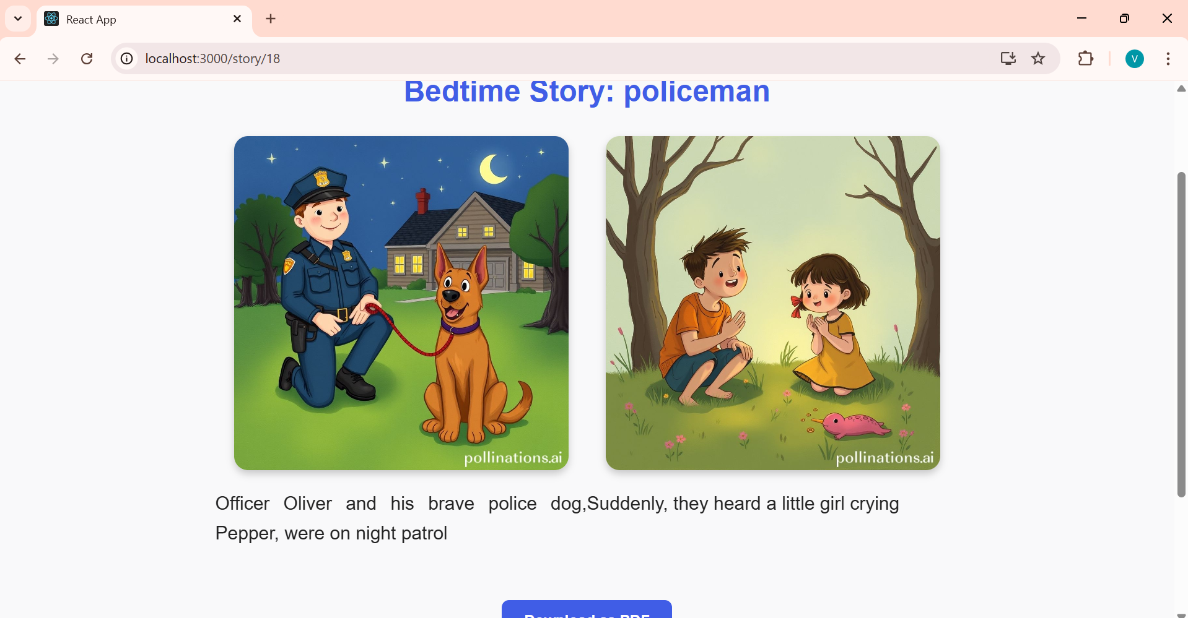

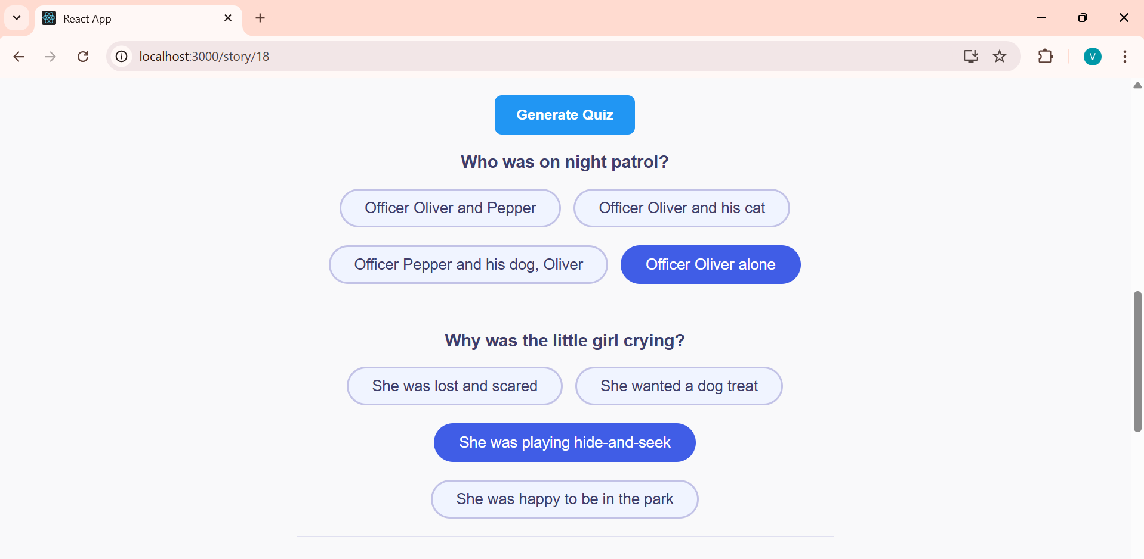

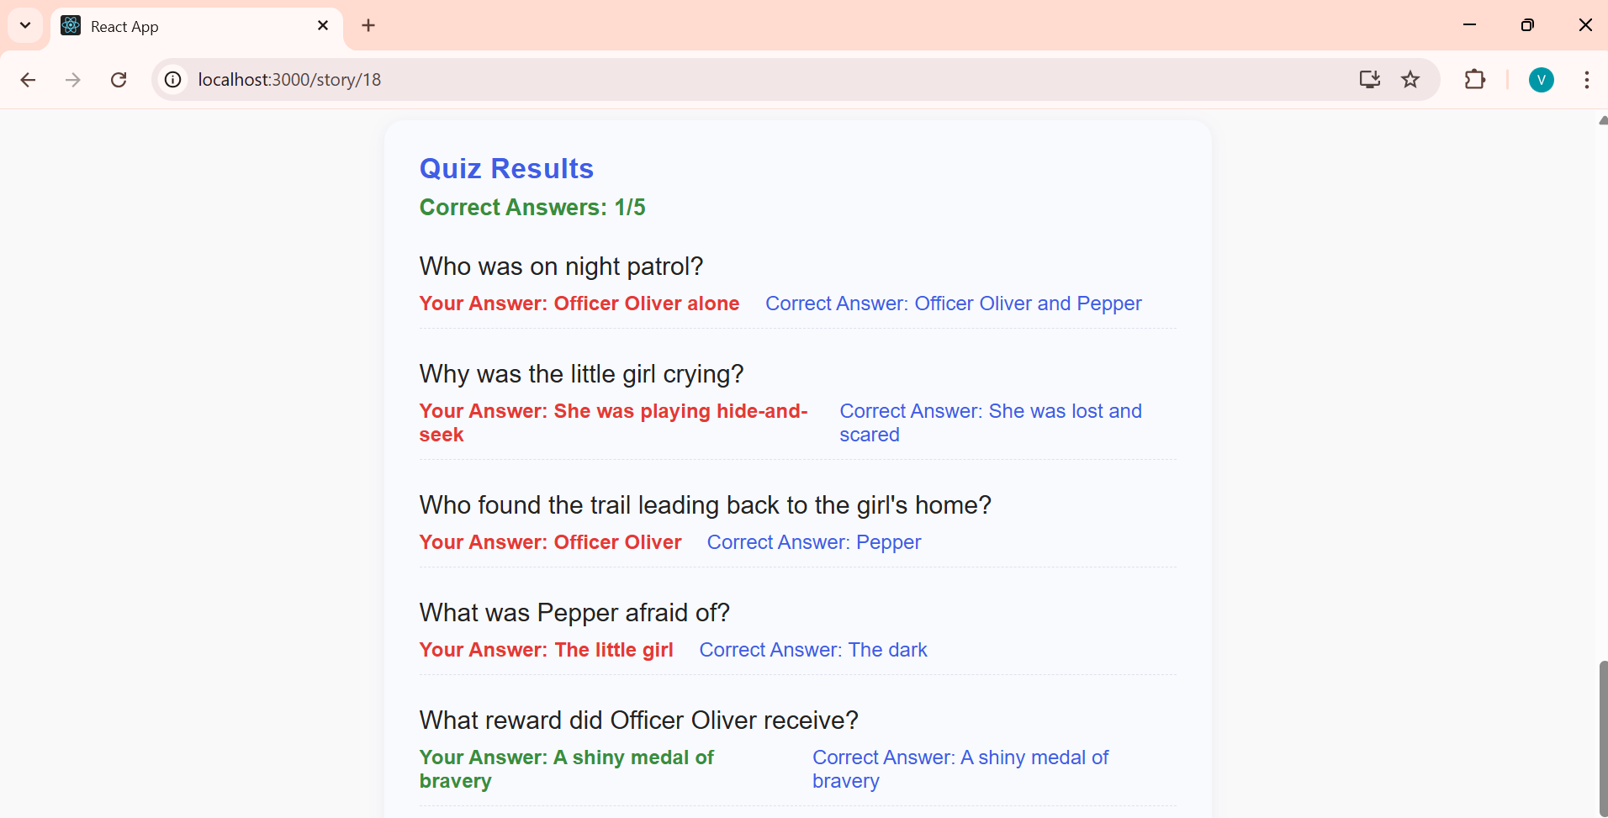

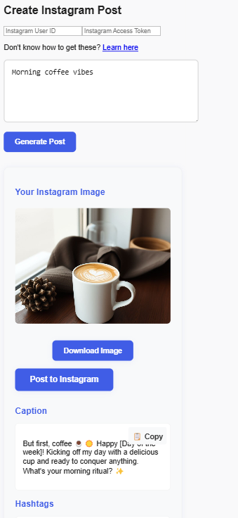

Discussion
The successful development and deployment of Skibidi Content demonstrate the practical viability of using lightweight, fine-tuned AI models for real-time, multimodal content generation. These findings are consistent with ongoing trends in AI research that emphasize efficient model deployment and modular integration for accessible user experiences. Similar to other AI content generation tools such as ChatGPT, DALL·E, and Google's Imagen, Skibidi Content reflects the growing capability of transformer-based models to produce coherent and context-aware outputs across various modalities, including text, audio, and images.
Compared to conventional content creation platforms that often require manual input or separate tools for different media types, Skibidi Content provides an integrated environment for generating storytelling elements, visual assets, voice narration, and social media content in a single user-friendly interface. This aligns with literature that highlights the importance of multimodal interaction in enhancing user engagement and learning outcomes, particularly for educational and entertainment applications.
The incorporation of Parameter-Efficient Fine-Tuning (PEFT) using LoRA allows the model to adapt to specific domains, such as children’s stories and educational narratives, without the need for large-scale retraining. This technique supports recent research advocating for efficient model personalization with limited computing resources, making it especially beneficial for developers working on constrained budgets or in low-resource environments.
However, the study is not without limitations. First, while the system performs well in generating child-friendly and educational content, it may not generalize effectively to more complex or abstract domains without further fine-tuning. Additionally, the reliance on third-party APIs (e.g., Pollinations.ai for image generation and gTTS for speech synthesis) introduces potential points of failure or latency, especially in offline or resource-constrained deployments. The platform’s initial training dataset was also narrowly scoped, which might limit its adaptability to more diverse or culturally nuanced storytelling styles.
Future research should explore broader datasets to improve model generalization and cultural diversity in generated content. Expanding language support and integrating real-time feedback mechanisms could allow the platform to adapt dynamically to user preferences and improve personalization. Additionally, optimizing processing speed and exploring edge-device deployment could further enhance accessibility and performance, particularly in educational contexts where infrastructure may be limited.
Overall, Skibidi Content contributes meaningfully to the evolving landscape of AI-assisted creativity and provides a promising framework for future innovations in automated storytelling, education, and content marketing.

Conclusion
This research outlines the successful development of Skibidi Content, an AI-driven content generation platform designed to make the content generation process fun, engaging, and highly interactive. At the heart of Skibidi Content is a focus on delivering the best UI/UX, ensuring that users not only experience seamless and efficient content creation but also enjoy a visually appealing and intuitive interface. By combining the power of fine-tuned language models, advanced multimedia tools, and web technologies, the platform transforms content creation into a delightful and creative experience.
Skibidi Content’s design prioritizes user experience with an emphasis on ease of use and interactive elements. A significant strength of the platform lies in its ability to generate multimodal content, including text, images, and audio, with just a prompt. Pollinations.ai is integrated for rich, visually captivating image generation, while gTTS (Google Text-to-Speech) allows for high-quality, natural-sounding audio. This combination of text, image, and audio generation makes the platform ideal for creating engaging, multimedia stories.Moreover, Skibidi Content includes an automated system for generating social media posts. By simply entering a prompt, users can instantly create an image, caption, and relevant hashtags. This feature takes the hassle out of content creation for platforms like Instagram, ensuring that users can easily generate and share their posts. What makes it even more powerful is the ability to directly post the generated content to the user’s Instagram account, streamlining the process and allowing for quick social media engagement without leaving the platform.
In conclusion, Skibidi Content represents a major step forward in the realm of AI-driven storytelling and content creation. Potential applications include digital content creation for media, entertainment, and marketing, educational tools for personalized learning experiences, and social media management. Recommendations for future enhancements include optimizing processing speed, expanding multimedia support, and integrating user feedback to improve customization and scalability.

References
[List all the references cited in your article in the appropriate format (e.g., APA, AMA, or specific formatting required by Cureus). Ensure all references are current and relevant.]
Kindly refer the following link for reference format.
https://www.cureusjournals.com/journal/computer-science/guide#!/author-instructions/references

[1] | P. &. B. H. M. Bhandari, Trustworthiness of Children Stories Generated by Large Language Models., arXiv preprint arXiv:2308.00073, 2023.
[2] | P. B. a. H. M. Brennan, Trustworthiness of Children Stories Generated by Large Language Models, arXiv:2308.00073v1 [cs.CL], 2023.

Figures and Tables
[Include any figures or tables referenced in the text. Each should have a descriptive caption. Ensure all visuals are high quality and legible.]
Note (1. The figure should be of 600dpi with clear labels on both axes 2. Table’s fist row should be Header)

Conflict of Interest Statement
The authors declare that they have no conflict of interest to disclose. The development and evaluation of the Skibidi Content platform were conducted solely for academic and research purposes, without any commercial or financial relationships that could be construed as a potential conflict of interest.

Acknowledgments
The authors would like to express their sincere gratitude to the Department of Information Technology at DYPCOE, Akurdi, Pune, for providing the necessary infrastructure and academic support throughout the development of this project. Special thanks to the faculty mentors for their continuous guidance, feedback, and encouragement during the research and implementation phases. The authors also acknowledge the open-source AI communities and platforms such as Hugging Face, Google Colab, and Pollinations.ai, whose tools and resources were instrumental in building and testing the Skibidi Content platform.
Note: Text format: Times New Romans, Text size:12

